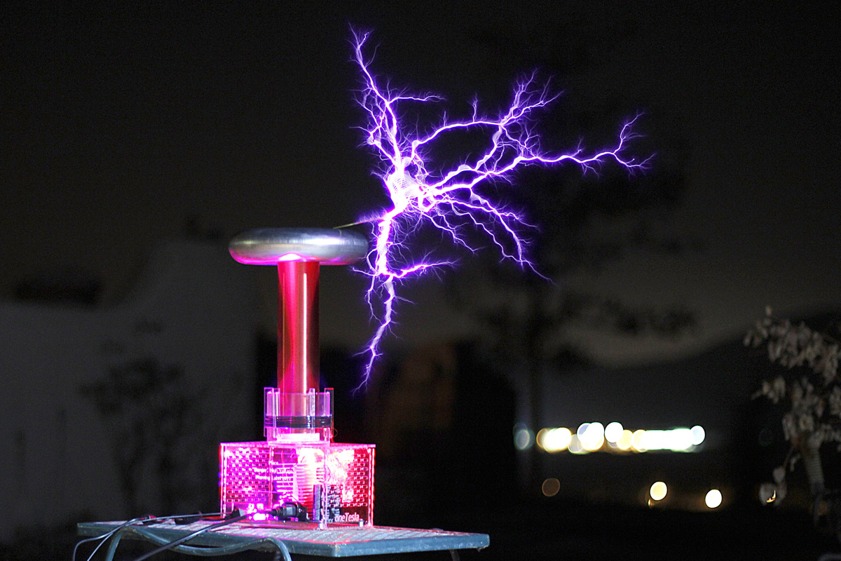

**Synthesla Project**

**Proposta - Controle**

Guilherme Costa, Lucas Constanzo, Nícolas Fonteyne e Nicolas Gentil

**Eletromagnetismo e Ondas – 4ENGMMB**

**São Paulo**

**2016**

**Sumário**

Descrição do protótipo 2

Bobina 3

Circuito 3

Orçamento 3

Considerações 5

# Descrição geral do projeto

Como projeto final da disciplina Modelagem e Controle

<https://pt.wikipedia.org/wiki/TRIAC>

<https://itp.nyu.edu/physcomp/labs/motors-and-transistors/using-a-transistor-to-control-high-current-loads-with-an-arduino/>

<http://www.electronics-tutorials.ws/power/triac.html>

<http://www.bristolwatch.com/ele/triacs.htm>

<https://www.circuitar.com/nanoshields/modules/triac/>

<http://www.st.com/content/ccc/resource/technical/document/application_note/25/74/20/71/0e/87/47/a2/DM00140117.pdf/files/DM00140117.pdf/jcr:content/translations/en.DM00140117.pdf>

<http://www.instructables.com/id/Digital-Potentiometer-MCP41100-and-Arduino/?ALLSTEPS>

<http://www.futurlec.com/SFMicrochip/MCP41100.shtml>